Worcester Women’s History Project at Worcester Historical Museum
invites you to
2024 Annual Meeting
October 30th at 6:00pm
Fletcher Auditorium
Worcester Historical Museum

Featuring
Celia Johnston Blue - Keynote Speaker
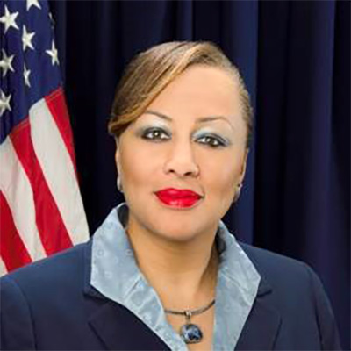

Celia Johnston Blue is a seasoned executive leader with over 25 years of experience in the private, public and nonprofit sectors. In 2015, she led the development and public launch of the Massachusetts Women of Color Coalition (MAWOCC) Inc. As President and CEO, she is leading the organization to realize its vision and mission, while strongly advocating for the voices of women of color to be heard.
This event is free and open to the public.
Worcester Historical Museum is located at 30 Elm Street, Worcester, MA 01609
For more information, please contact:
Barbaraguertin@worcesterhistory.net or 508-753-8278 x111

